s

REPIF1: SOFRA Jonathan
Indoor Climate Station
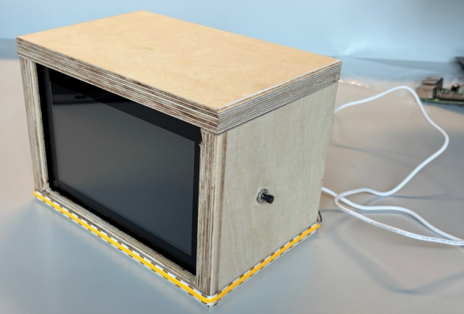

Portable Indoor Feedback

Contents
Installation and Configuration of RaspberryPI 3
Installation of the Program 3
Using the official Imager 3
Hardware Part 5
Touching the Touchscreen 6
Starting the RaspberryPI with the touchscreen 7
Setting up VNC Server for remote desktop 8
Setting up a static IP address for the Ethernet Interface 10
Enabling I2C Interface 11
Installing Docker and PHP with Apache2 11
Installing Firmware Files and configuring them 12
Autostart firmware 14
Creating conceptual data and databases 15
Conceptual Data Model (MCD/CDM) 15
Logical Data Model (LDM/MLD) 15
SQL Code for Logical Data Model 16
Sample Data we will provide to our Database 17
Using Mysql (MariaDB) on Linux 18
Installing mysql server (mariadb) 18
Logging in and inserting data 18
Exporting database as a SQL file 18
Creating the WebServer 19
Enabling the firewall 19
Installing Apache2, SSH, MariaDB, PHPMyAdmin and PHP 19
Setting up the database 19
Creating an Apache2 configuration 20

Installation and Configuration of RaspberryPI
On the RaspberryPI official’s website, a tool called RaspBerryPI Imager can be installed to flash the RaspberryPI OS on a SD card that we would later on use for the RaspberryPI itself.
We will later on also configure the hardware, meaning mounting also the touchscreen.

Installation of the Program
Head to the website: https://www.raspberrypi.com/software and download Raspberry Pi Imager.
This involves us to do a normal and easy setup I will document.
The first step of the setup is just a basic language selector, in my case I will select English.
The first fews steps, there is nothing special to do except clicking Next until it’s successfully downloader on our system.

Using the official Imager
Now after the installation, you should have the same program right here:
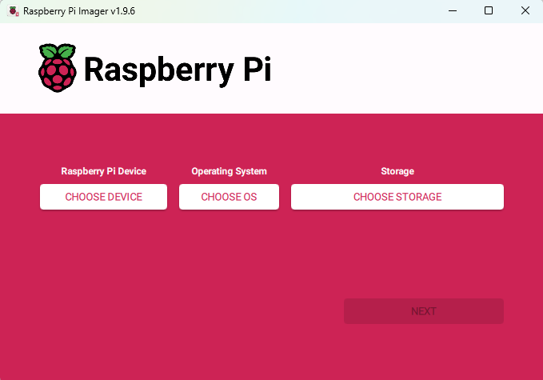
It is pretty self explanatory, select the correct Device, Operating System and Storage.
In our case we will select RaspberryPi 4 as the Device, the RaspberryPi OS 64-bit and the storage, our SD card mounted on a usb sd-card reader/writer.
After clicking Next, we have to Edit Settings of the OS customization, as we have to set up some important details.
We will set-up the hostname so that we can later on SSH into it without IP by using the local domain, we will also setup the username and password, the wireless LAN as the project should be wireless, and optionally the keyboard layout and timezone so that we don’t have to deal with it after the installation of the OS. And most importantly we will also enable SSH service.
Here is my configuration:
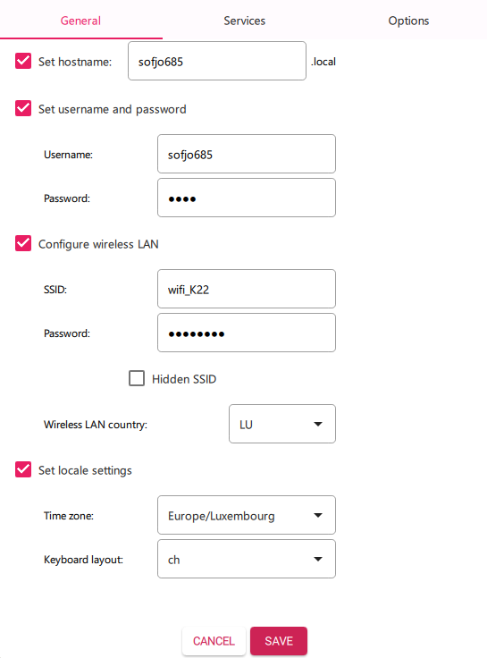
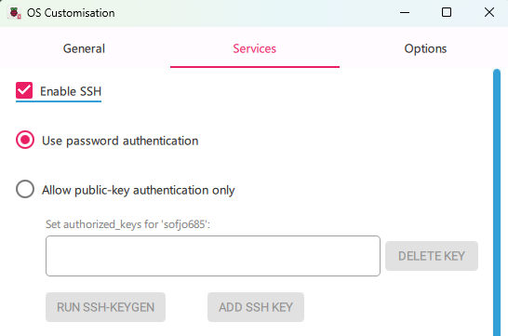
After editing the settings we click Save and we apply the OS customisation settings by clicking YES.
If it prompts us to click on YES to erase storage, do it.
After a small wait, the installation should be finished, and we will pursue on the configuration and mounting of the hardware.

Hardware Part
After the OS is installed into our SD card we will start by the hardware part, meaning unboxing of the necessary components, meaning:
- The Power Supply
- The RaspberryPI Model 4B 1GB RAM
- The Touchscreen
- A screwdriver

Here is a photo of all the components necessary for the mount of the touchscreen
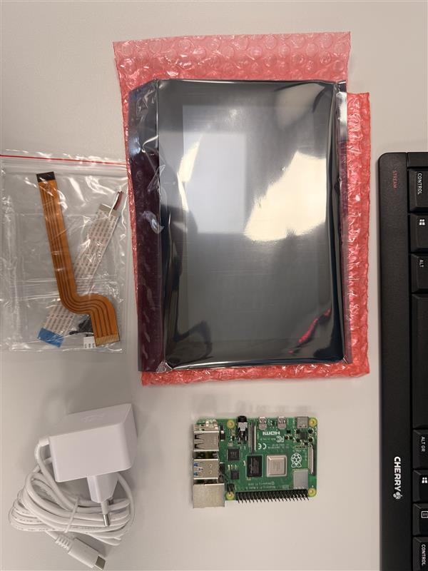

Touching the Touchscreen
We will now start connecting the touchscreen. Here is an image from the official documentation showing how it should be done.
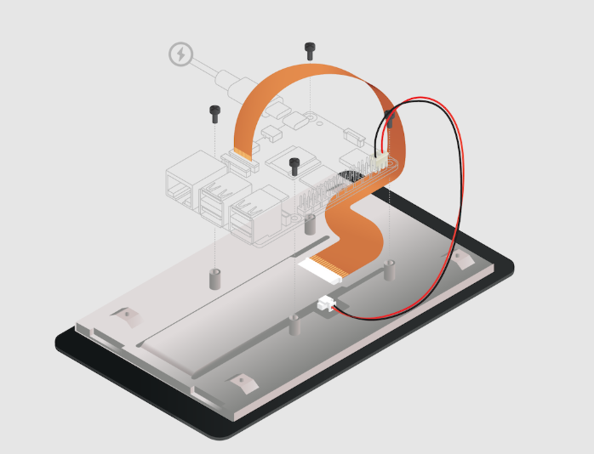

And here is mine done.
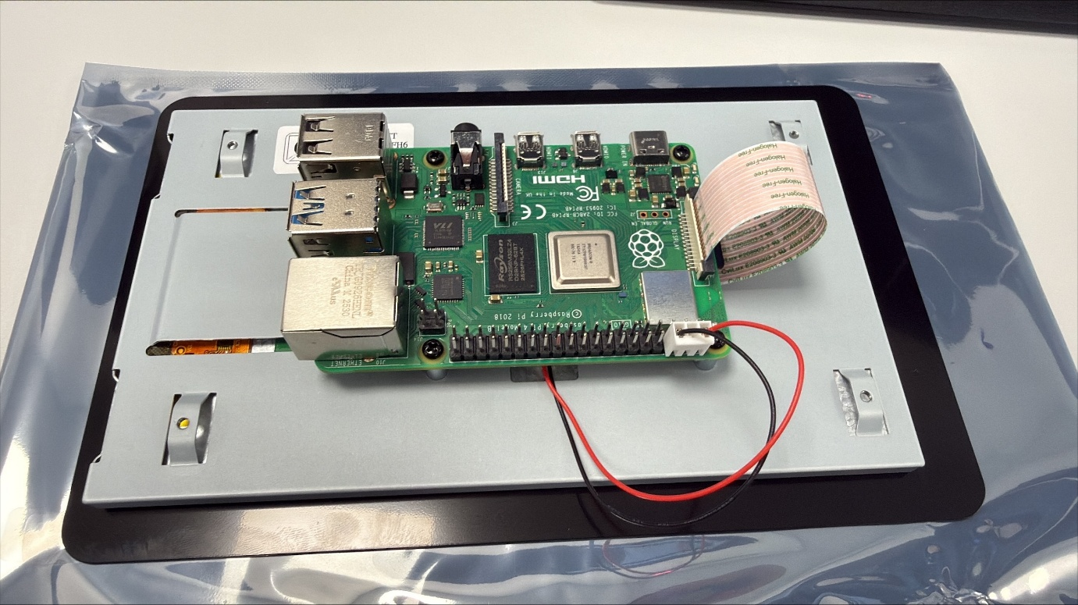

Starting the RaspberryPI with the touchscreen

I will now plug the RaspberryPi using the Power Supply cable.
After the booting of the OS, we see that the Display mode is set as default as Portrait.
We will immediately change it as LandScape.
In the RaspberryPi Control Center, head up to the Screens section, the click on Screens -> DSI-1 -> Orientation -> Right.
It should now be displayed as Landscape.
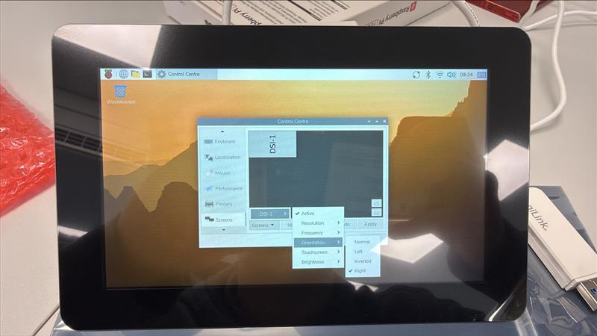
Note: You might need to reboot the OS to ensure that everything is displayed correctly. (We will also do an update using sudo apt update && sudo apt upgrade)

Setting up VNC Server for remote desktop
For this step, we will use ssh to connect remotely to the RaspberryPI.
I personally recommend MobaXTerm as it is really user friendly and easy to use.
The IP is always shown when raspberry just got connected to the network.
The command we are going to use is :
sudo raspi-config

And you should see this
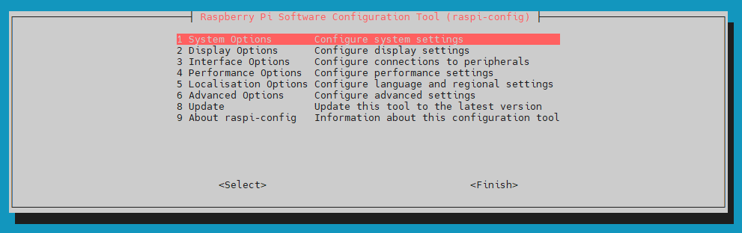

Then you should active VNC by going through the 3rd row named “Interface Options” then press ENTER on VNC to enable VNC Server.
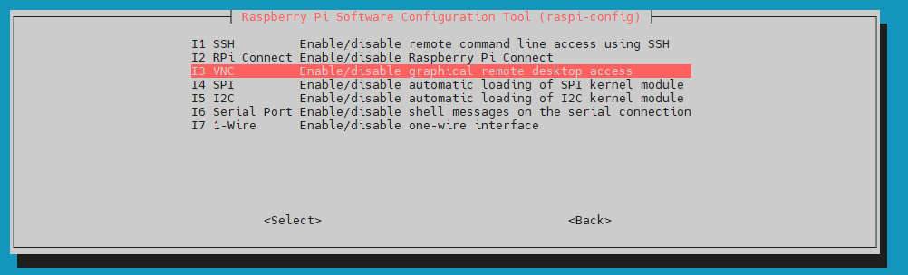

Connecting to our RaspberryPI through VNC
For this step we will use RealVNC Viewer.
It is really user friendly, you should just put the IP address of your RaspberryPI in the searchbar then press ENTER.
Then connect as normal to your user.
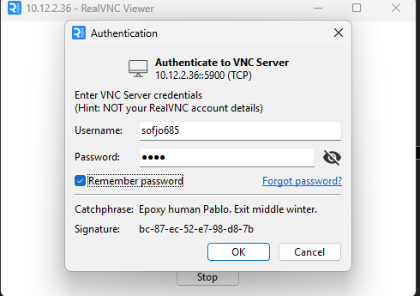

Setting up a static IP address for the Ethernet Interface
To set up a static IP, click on the network icon on the top task bar top-right, the click on Advanced Options -> Edit Connections...
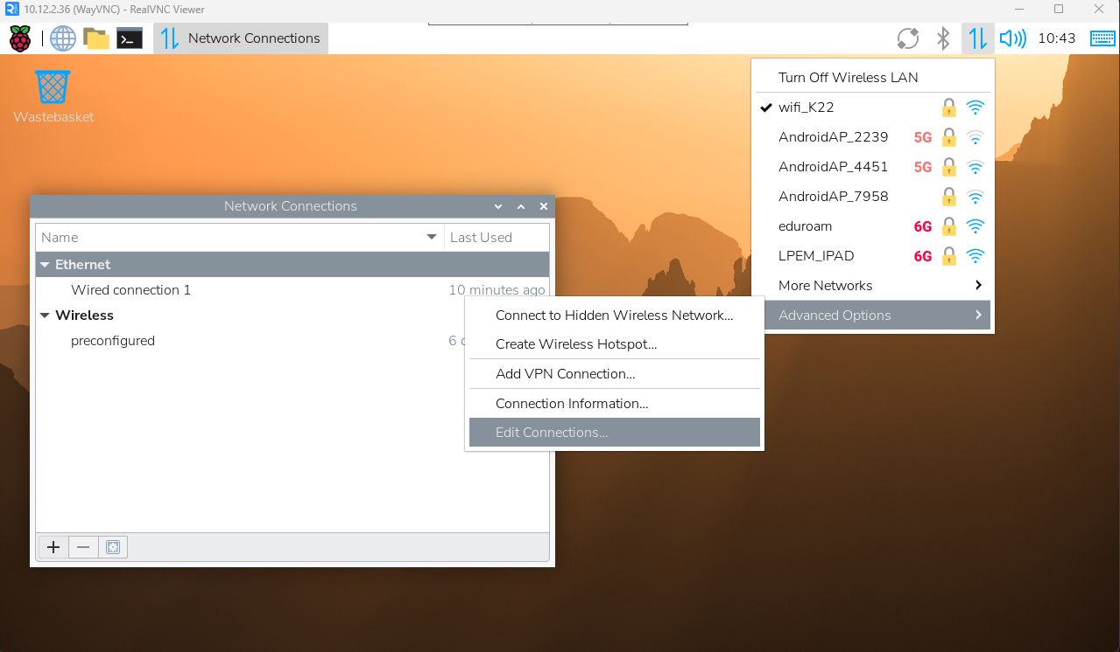
You will see your network interfaces, wireless and ethernet.
Click on Wired connection 1 then click the Option icon bottom-left.
Go to IPv4 Settings and change method to Manual and set the correct IP, I will use the last 2 digits of my IAM Code.
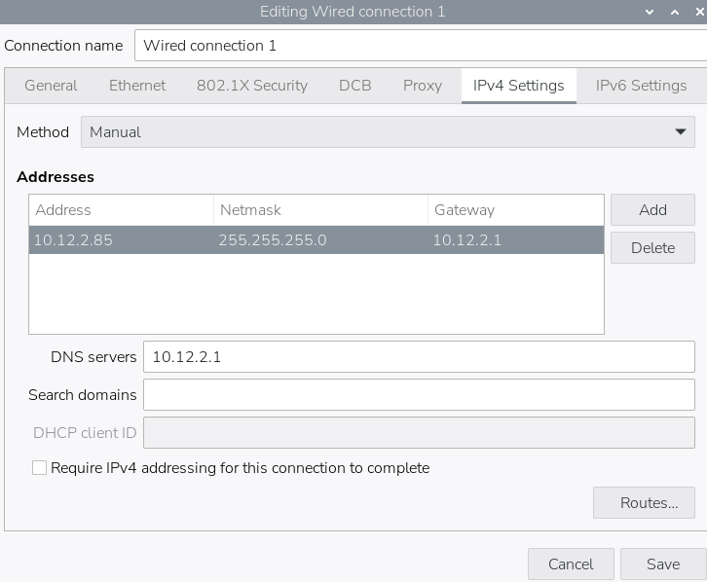

Enabling I2C Interface
As we did to enable VNC Server, we will re-use the sudo raspi-config command to enable the I2C Interface, it is also located in the same section as VNC.
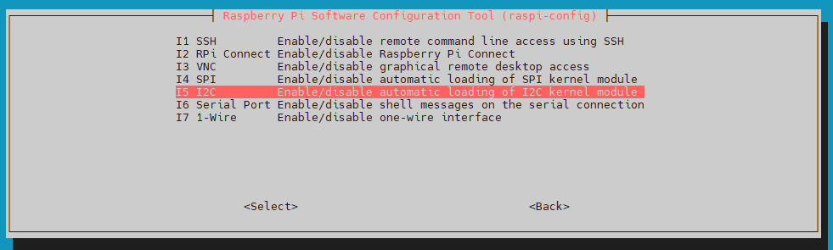

Installing Docker and PHP with Apache2
Quick install Docker using installation script
curl -sSL https://get.docker.com | sh

This installer will install everything on its own.
After the installation is done, we will use a docker container to run php with apache2.
sudo docker run -d --name php -p 8080:80 -v /tmp/station:/tmp/station -v /var/www/html:/var/www/html php:8.4-apache

Install also the Python dependencies
sudo apt install python3-smbus2 python3-venv python3-requests

cd /opt/station
sudo python3 -m venv venv
source venv/bin/activate
pip install bh1750 bme280-sensor mq135-sensor

Installing Firmware Files and configuring them
In this project, we need some firmware files to ensure the correct functionality of our station.
The URL is the following one: Ressourcen.zip
You shall connect to your IAM to gain access to the download
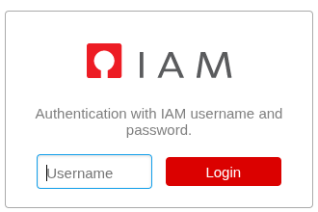
After logging in, you should download the ZIP file
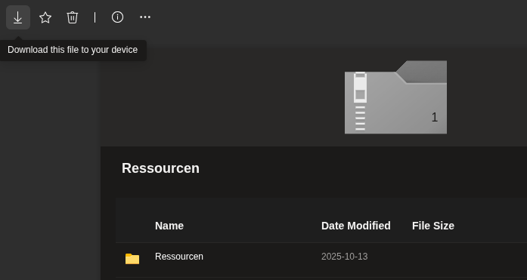
Now we will set them in the correct folders with the correct permissions.
Here are the commands:
sudo mkdir -p /opt/station/www
sudo mkdir -p /var/station
sudo mkdir -p /tmp/station
sudo mkdir -p /var/www/html
sudo chown -R sofjo685:sofjo685 /opt/station /var/station /tmp/station /var/www/html
In the ZIP file, we will extract all files from Resourcen/Firmware und Scripts/ to /opt/station
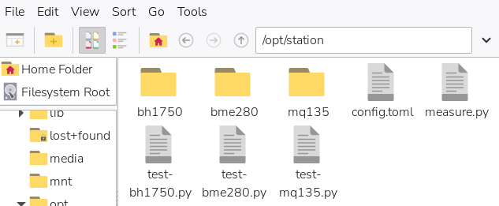
We will now copy the index.php file from the ZIP archive to /var/www/html as the Docker container mounts /var/www/html directly.
Edit config.toml file, for now we will only change the station_serial to an unique number and the path to /opt/station
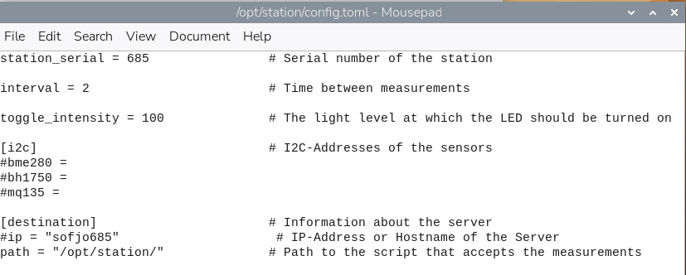

Autostart firmware
Modify or create autostart file using command
nano ~/.config/labwc/autostart

You will put this code, I commented each section to explain what they do.
#!/bin/bash
# Create necessary directories
mkdir -p /tmp/station

# Start Docker container with website from /var/www/html
sudo docker start php || docker run -d --name php -p 8080:80 -v /tmp/station:/tmp/station -v /var/www/html:/var/www/html php:8.4-apache

# Wait for services to start
sleep 5

# Start measurement script using virtual environment
cd /opt/station
source venv/bin/activate
python3 measure.py &

# Wait for measurements to initialize
sleep 10

# Start browser in kiosk mode (fullscreen)
chromium --kiosk http://localhost:8080 &

Now make sure that the file has the correct permission to execute
sudo chmod +x ~/.config/labwc/autostart

After rebooting, you should now see the web interface in fullscreen running like this:
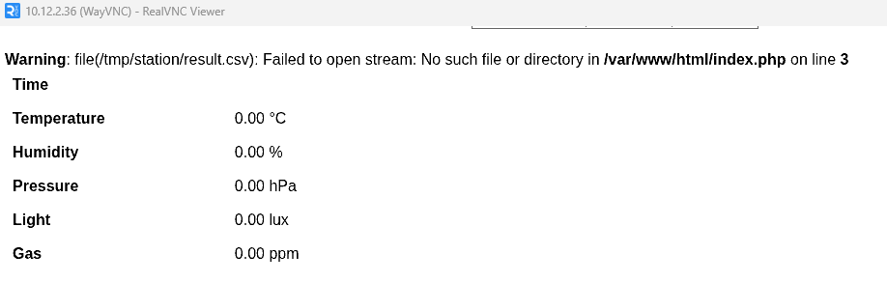
Note: If you see any errors in the beginning, just ignore them.

Creating conceptual data and databases

Conceptual Data Model (MCD/CDM)
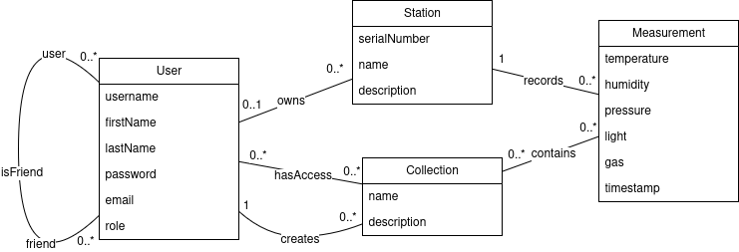

Logical Data Model (LDM/MLD)
Here I did my logical data model also by including their relations and data-types.
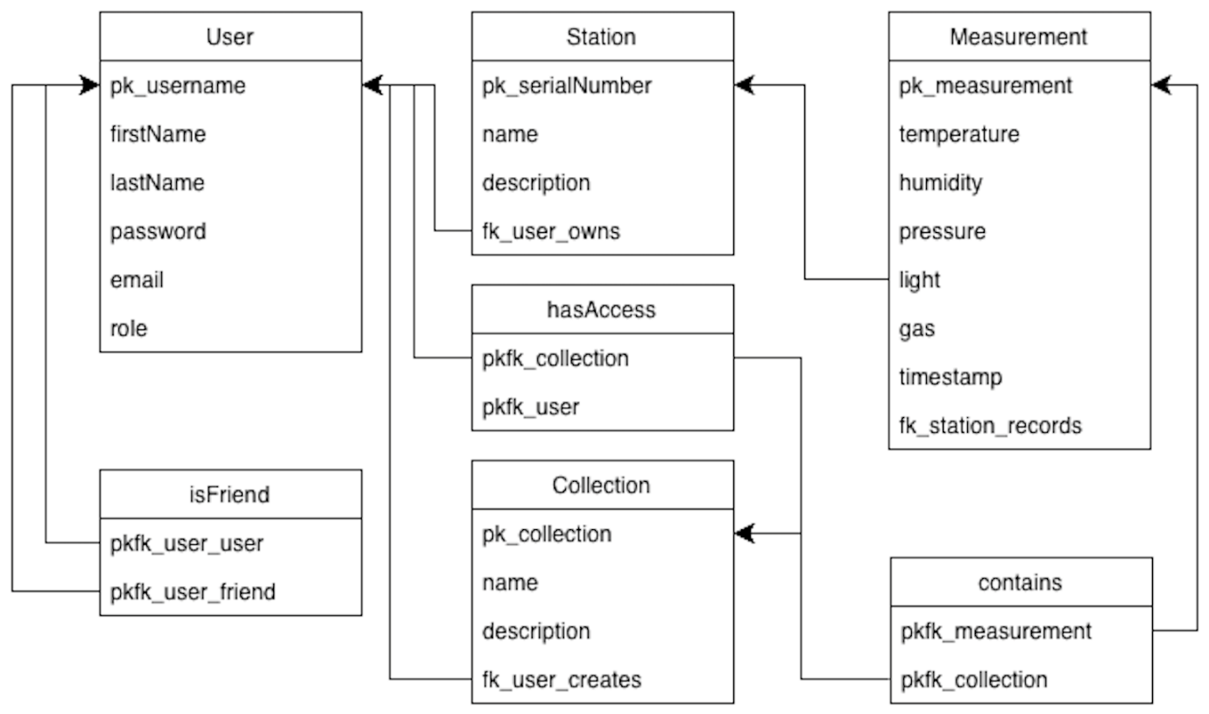

SQL Code for Logical Data Model
SET SQL_MODE = "NO_AUTO_VALUE_ON_ZERO";
START TRANSACTION;
SET time_zone = "+00:00";
CREATE DATABASE IF NOT EXISTS `sofjo685_pif` DEFAULT CHARACTER SET utf8mb4 COLLATE utf8mb4_general_ci;
USE `sofjo685_pif`;
CREATE TABLE `collection` (
`pk_collection` int NOT NULL,
`name` varchar(50) COLLATE utf8mb4_general_ci DEFAULT NULL,
`description` text COLLATE utf8mb4_general_ci,
`fk_user_creates` varchar(50) COLLATE utf8mb4_general_ci NOT NULL
) ENGINE=InnoDB DEFAULT CHARSET=utf8mb4 COLLATE=utf8mb4_general_ci;
CREATE TABLE `contains` (
`pkfk_collection` int NOT NULL,
`pkfk_measurement` int NOT NULL
) ENGINE=InnoDB DEFAULT CHARSET=utf8mb4 COLLATE utf8mb4_general_ci;
CREATE TABLE `hasaccess` (
`pkfk_user` varchar(50) COLLATE utf8mb4_general_ci NOT NULL,
`pkfk_collection` int NOT NULL
) ENGINE=InnoDB DEFAULT CHARSET=utf8mb4 COLLATE utf8mb4_general_ci;
CREATE TABLE `isfriend` (
`pkfk_user_user` varchar(50) COLLATE utf8mb4_general_ci NOT NULL,
`pkfk_user_friend` varchar(50) COLLATE utf8mb4_general_ci NOT NULL
) ENGINE=InnoDB DEFAULT CHARSET=utf8mb4 COLLATE utf8mb4_general_ci;
CREATE TABLE `measurement` (
`pk_measurement` int NOT NULL,
`temperature` decimal(5,2) NOT NULL,
`humidity` decimal(5,2) NOT NULL,
`pressure` decimal(6,2) NOT NULL,
`light` decimal(6,2) NOT NULL,
`gas` decimal(6,2) NOT NULL,
`timestamp` datetime NOT NULL,
`fk_station_records` varchar(50) COLLATE utf8mb4_general_ci NOT NULL
) ENGINE=InnoDB DEFAULT CHARSET=utf8mb4 COLLATE utf8mb4_general_ci;
CREATE TABLE `station` (
`pk_serialNumber` varchar(50) COLLATE utf8mb4_general_ci NOT NULL,
`name` varchar(100) COLLATE utf8mb4_general_ci DEFAULT NULL,
`description` text COLLATE utf8mb4_general_ci,
`fk_user_owns` varchar(50) COLLATE utf8mb4_general_ci DEFAULT NULL
) ENGINE=InnoDB DEFAULT CHARSET=utf8mb4 COLLATE utf8mb4_general_ci;
CREATE TABLE `user` (
`pk_username` varchar(50) COLLATE utf8mb4_general_ci NOT NULL,
`firstName` varchar(50) COLLATE utf8mb4_general_ci NOT NULL,
`lastName` varchar(50) COLLATE utf8mb4_general_ci NOT NULL,
`password` varchar(255) COLLATE utf8mb4_general_ci NOT NULL,
`email` varchar(50) COLLATE utf8mb4_general_ci NOT NULL,
`role` enum('User','Admin') COLLATE utf8mb4_general_ci NOT NULL DEFAULT 'User'
) ENGINE=InnoDB DEFAULT CHARSET=utf8mb4 COLLATE utf8mb4_general_ci;
ALTER TABLE `collection`
ADD PRIMARY KEY (`pk_collection`),
ADD KEY `fkc_user_creates_collection` (`fk_user_creates`);
ALTER TABLE `contains`
ADD PRIMARY KEY (`pkfk_collection`,`pkfk_measurement`),
ADD KEY `fkc_contains_measurement` (`pkfk_measurement`);
ALTER TABLE `hasaccess`
ADD PRIMARY KEY (`pkfk_user`,`pkfk_collection`),
ADD KEY `fkc_hasaccess_collection` (`pkfk_collection`);
ALTER TABLE `isfriend`
ADD PRIMARY KEY (`pkfk_user_user`,`pkfk_user_friend`),
ADD KEY `fkc_isfriend_friend` (`pkfk_user_friend`);
ALTER TABLE `measurement`
ADD PRIMARY KEY (`pk_measurement`),
ADD KEY `fkc_station_records_measurement` (`fk_station_records`);
ALTER TABLE `station`
ADD PRIMARY KEY (`pk_serialNumber`),
ADD KEY `fkc_user_owns_station` (`fk_user_owns`);
ALTER TABLE `user`
ADD PRIMARY KEY (`pk_username`),
ADD UNIQUE KEY `email` (`email`);
ALTER TABLE `collection`
MODIFY `pk_collection` int NOT NULL AUTO_INCREMENT;
ALTER TABLE `measurement`
MODIFY `pk_measurement` int NOT NULL AUTO_INCREMENT;
ALTER TABLE `collection`
ADD CONSTRAINT `fkc_user_creates_collection` FOREIGN KEY (`fk_user_creates`) REFERENCES `user` (`pk_username`) ON DELETE CASCADE ON UPDATE CASCADE;
ALTER TABLE `contains`
ADD CONSTRAINT `fkc_contains_collection` FOREIGN KEY (`pkfk_collection`) REFERENCES `collection` (`pk_collection`) ON DELETE CASCADE ON UPDATE CASCADE,
ADD CONSTRAINT `fkc_contains_measurement` FOREIGN KEY (`pkfk_measurement`) REFERENCES `measurement` (`pk_measurement`) ON DELETE CASCADE ON UPDATE CASCADE;
ALTER TABLE `hasaccess`
ADD CONSTRAINT `fkc_hasaccess_collection` FOREIGN KEY (`pkfk_collection`) REFERENCES `collection` (`pk_collection`) ON DELETE CASCADE ON UPDATE CASCADE,
ADD CONSTRAINT `fkc_hasaccess_user` FOREIGN KEY (`pkfk_user`) REFERENCES `user` (`pk_username`) ON DELETE CASCADE ON UPDATE CASCADE;

ALTER TABLE `isfriend`
ADD CONSTRAINT `fkc_isfriend_friend` FOREIGN KEY (`pkfk_user_friend`) REFERENCES `user` (`pk_username`) ON DELETE CASCADE ON UPDATE CASCADE,
ADD CONSTRAINT `fkc_isfriend_user` FOREIGN KEY (`pkfk_user_user`) REFERENCES `user` (`pk_username`) ON DELETE CASCADE ON UPDATE CASCADE;
ALTER TABLE `measurement`
ADD CONSTRAINT `fkc_station_records_measurement` FOREIGN KEY (`fk_station_records`) REFERENCES `station` (`pk_serialNumber`) ON DELETE CASCADE ON UPDATE CASCADE;
ALTER TABLE `station`
ADD CONSTRAINT `fkc_user_owns_station` FOREIGN KEY (`fk_user_owns`) REFERENCES `user` (`pk_username`) ON DELETE SET NULL ON UPDATE CASCADE;
COMMIT;

Sample Data we will provide to our Database
To try our current data model, we will provide it this sample data.
START TRANSACTION;
INSERT INTO `user` (pk_username, firstName, lastName, password, email, role) VALUES
('alice','Alice','Martin','pass','alice@mail.com','User'),
('bob','Bob','Dupont','pass','bob@mail.com','User'),
('carol','Carol','Weber','pass','carol@mail.com','User'),
('dave','Dave','Schmit','pass','dave@mail.com','User'),
('eva','Eva','Klein','pass','eva@mail.com','User'),
('frank','Frank','Muller','pass','frank@mail.com','User'),
('gina','Gina','Rossi','pass','gina@mail.com','User'),
('henry','Henry','Lopez','pass','henry@mail.com','User'),
('irene','Irene','Novak','pass','irene@mail.com','User'),
('admin','Admin','Root','adminpass','admin@mail.com','Admin');
INSERT INTO `station` (pk_serialNumber, name, description, fk_user_owns) VALUES
('ST001','Living Room','Main room sensor','alice'),
('ST002','Bedroom','Night sensor','bob'),
('ST003','Kitchen','Cooking area','carol'),
('ST004','Garage','Car area','dave'),
('ST005','Office','Work room','eva'),
('ST006','Basement','Storage','frank'),
('ST007','Garden','Outdoor','gina'),
('ST008','Hall','Entrance','henry'),
('ST009','Bathroom','Humidity zone','irene'),
('ST010','Lab','Test unit','admin');
INSERT INTO `measurement` (pk_measurement, temperature, humidity, pressure, light, gas, timestamp, fk_station_records) VALUES
(1,21.5,45.2,1012.5,300,120,'2025-01-01 10:00:00','ST001'),
(2,22.0,44.1,1011.8,320,110,'2025-01-01 10:05:00','ST002'),
(3,20.8,50.0,1013.0,280,130,'2025-01-01 10:10:00','ST003'),
(4,18.2,55.5,1010.2,150,200,'2025-01-01 10:15:00','ST004'),
(5,23.1,40.3,1014.1,400,90,'2025-01-01 10:20:00','ST005'),
(6,19.6,60.0,1009.9,100,250,'2025-01-01 10:25:00','ST006'),
(7,16.4,70.1,1008.7,500,80,'2025-01-01 10:30:00','ST007'),
(8,21.9,42.8,1012.0,350,115,'2025-01-01 10:35:00','ST008'),
(9,24.0,65.2,1011.3,200,180,'2025-01-01 10:40:00','ST009'),
(10,22.5,48.9,1013.5,450,100,'2025-01-01 10:45:00','ST010');
INSERT INTO `collection` (pk_collection, name, description, fk_user_creates) VALUES
(1,'Home','Home data','alice'),
(2,'Sleep','Night stats','bob'),
(3,'Cooking','Kitchen logs','carol'),
(4,'Garage','Garage history','dave'),
(5,'Office','Work environment','eva'),
(6,'Basement','Storage tracking','frank'),
(7,'Garden','Outdoor metrics','gina'),
(8,'Hall','Entrance logs','henry'),
(9,'Bathroom','Humidity checks','irene'),
(10,'Lab','Experimental data','admin');
INSERT INTO `contains` (pkfk_collection, pkfk_measurement) VALUES
(1,1),(2,2),(3,3),(4,4),(5,5),
(6,6),(7,7),(8,8),(9,9),(10,10);
INSERT INTO `hasaccess` (pkfk_user, pkfk_collection) VALUES
('alice',1),('bob',2),('carol',3),('dave',4),('eva',5),
('frank',6),('gina',7),('henry',8),('irene',9),('admin',10);
INSERT INTO `isfriend` (pkfk_user_user, pkfk_user_friend) VALUES
('alice','bob'),
('bob','carol'),
('carol','dave'),
('dave','eva'),
('eva','frank'),
('frank','gina'),
('gina','henry'),
('henry','irene'),
('irene','alice'),
('admin','alice');

COMMIT;

Using Mysql (MariaDB) on Linux

Installing mysql server (mariadb)
First, before creating any databases and importing data into them, we need to install the mysql server on the RaspberryPI.
Head-up in your SSH and execute the command
sudo apt update && sudo apt install mariadb-server

Logging in and inserting data
After installing the mariadb server, we will insert our previousely created data models.
At first, we need to login into the mariadb cli to make changes directly in the database system.
Execute command.
Sudo mysql -u root -p
Note: They might ask for your root password.

After this just execute the whole block of mysql code that we created previously on page 16.
After executing this, use the sample data I provided also above, in page 17.
Note: you may exit now mariadb with “exit” command.

Exporting database as a SQL file
Exporting a database can be useful when we want to migrate the data to another database or to just take a backup for safety.
A very simple command exists for it and it is
mysqldump -u<username> -p<password> database_name table_name > dumpfile_name.sql
Note: Make sure <username>, <password>, database_name and table name matches yours!

Creating the WebServer

Enabling the firewall
Using a VM hosted on my personal Proxmox Server, I installed Ubuntu 24.04 LTS server with 4 cores, 8GB of ram and 150GB of storage.
As a port forwarding, I will put the port number 2202 and 8000, 8000 for the webserver, 2202 for ssh.
For the port forwarding we may use UFW firewall to prevent opening non-desired ports to public.
Sudo ufw allow 2202
Sudo ufw allow 8000
Sudo ufw enable

Installing Apache2, SSH, MariaDB, PHPMyAdmin and PHP
Also always update and upgrade server, we will later on install Apache2 , OpenSSH-server and PHP
Sudo apt update && sudo apt upgrade
Sudo apt install apache2 php openssh-server mariadb-server

Setting up the database
Before starting with the actual website code, we will create its database and the correctc user that will have access later on, on the website.
First log into MariaDB as root
sudo mysql -u root

Create the database and user
CREATE DATABASE sofjo685_pif;
CREATE USER 'sofjo685'@'localhost' IDENTIFIED BY 'your_secure_password_here';
GRANT ALL PRIVILEGES ON sofjo685_pif.* TO 'sofjo685'@'localhost';
FLUSH PRIVILEGES;
EXIT;
(Note: Change “your_secure_password_here” with your actual desired password)

Creating an Apache2 configuration
For the server-side website, we need to create an Apache2 configuration, this configuration will for now simply tell the webserver which port to listen to and what location to load the files to.
First create config file
sudo nano /etc/apache2/sites-available/sofjo685.conf
(Note: Change to your IAM)

And then paste this simple configuration
<VirtualHost *:8000>
ServerName jona.ipv64.net
ServerAlias www.jona.ipv64.net

DocumentRoot /var/www/sofjo685

<Directory /var/www/sofjo685>
Options Indexes FollowSymLinks
AllowOverride All
Require all granted
</Directory>

ErrorLog ${APACHE_LOG_DIR}/sofjo685_error.log
CustomLog ${APACHE_LOG_DIR}/sofjo685_access.log combined
</VirtualHost>
(Note: Change to your IAM for the ServerName, DocumentRoot, Directory and both type of logs.)

Create the folder where you webserver will load the webfiles
sudo mkdir -p /var/www/sofjo685/

Enable the WebServer
sudo a2ensite sofjo685.conf
sudo systemctl reload apache2

Create phpmyadmin configuration to be able to manage database and insert previousely created SQL Query of the whole database
First remove old configuration in conf-available
sudo rm /etc/apache2/conf-available/phpmyadmin.conf

Second create create config in sites-avilable
Sudo nano /etc/apache2/sites-available/phpmyadmin.conf

Third insert this
<VirtualHost *:8000>
ServerName pma.jona.ipv64.net

DocumentRoot /usr/share/phpmyadmin

<Directory /usr/share/phpmyadmin>
Options FollowSymLinks
DirectoryIndex index.php
Require all granted

<IfModule mod_php.c>
php_flag display_errors On
php_value upload_max_filesize 256M
php_value post_max_size 256M
php_value max_execution_time 360
</IfModule>
</Directory>
<Directory /usr/share/phpmyadmin/templates>
Require all denied
</Directory>

<Directory /usr/share/phpmyadmin/libraries>
Require all denied
</Directory>

ErrorLog ${APACHE_LOG_DIR}/pma_error.log
CustomLog ${APACHE_LOG_DIR}/pma_access.log combined
</VirtualHost>

And last, enable website
sudo a2ensite /etc/apache2/sites-available/phpmyadmin.conf
sudo systemctl reload apache2
Now if you try to browse and can’t see any output, you might need to include the port “8000” to the apache2 ports config
sudo nano /etc/apache2/ports.conf

And add inside
Listen 8000

Then reload apache2 and you will see this

And in pma.yourdomain.name


You now successfully installed and configured phpmyadmin and ubuntu!

Creating the website
Project Overview
The Indoor Climate Monitoring System is a web application designed to collect, store, and visualize environmental data from IoT sensor stations. Users can register weather stations, view real-time measurements, create data collections, and share access with friends.
Core Functionality
- User Management: Registration, login, profile editing, password reset with email verification
- Station Management: Register, claim, and manage sensor stations
- Data Collection: Create collections of measurements across multiple stations with date ranges
- Social Features: Friend system with request/accept workflow and collection sharing
- Admin Panel: User management, station provisioning, secret auditing
- Real-time Dashboard: Live charts with auto-refresh for temperature, humidity, and air quality
Architecture
Application Structure
The system follows a three-tier architecture with frontend, backend, and database layers. The frontend uses jQuery and Chart.js for real-time visualization (e.g. charts), the backend processes requests via PHP with PDO, and MySQL stores all persistent data.
Request Flow
1. User Request → Browser sends AJAX request with CSRF token
2. PHP Handler → Validates CSRF, authenticates session
3. Logic → Processes request, interacts with database
4. JSON Response → Returns structured data to frontend
5. UI Update → JavaScript updates DOM with SweetAlert2 notifications

Technology Stack
Backend Technologies
Technology | Version | Purpose
PHP | 7.3+ | Server-side processing
PDO | - | Database access layer
MySQL/MariaDB | 5.7+ | Database
PHPMailer | 6.x | Email delivery
Brevo | - | SMTP provider
Frontend Technologies
Technology | Version | Purpose
HTML5/CSS3 | - | Structure and styling
jQuery | 3.6.0 | DOM manipulation, AJAX
Chart.js | Latest | Real-time visualization

Database Design
The database uses normalized relational design with foreign key constraints and cascading deletes. Key tables include user, station, measurement, collection, and friend system tables.
Core Tables
• user: Stores user credentials, profile info, and role (User/Admin)
• station: Represents IoT sensor stations with serial number, name, and HMAC secret
• measurement: Records sensor readings (temperature, humidity, air quality) with timestamps
• collection: User-created groupings of measurements across multiple stations
• contains: Junction table linking measurements to collections
• hasaccess: Tracks which users have access to which collections
• isfriend: Represents established friend relationships (bidirectional)
• friend_request: Manages pending, accepted, or declined friend requests

Security Features
CSRF Protection: Token-based with 1-hour expiry using timing-safe comparison (hash_equals)
Session Security: HttpOnly cookies, SameSite=Lax, secure flag for HTTPS
Password Hashing: bcrypt via password_hash() with PASSWORD_DEFAULT algorithm
API Authentication: HMAC-SHA256 signature verification with station secrets
Rate Limiting: 60 requests/minute per station with Redis primary + DB fallback
Input Validation: Sensor readings validated against realistic ranges (-50-60°C, 0-100% humidity)
Code Example: CSRF Token Validation
function validate_csrf($token) {
if (empty($_SESSION['csrf_token'])) return false;
if (time() - $_SESSION['csrf_token_time'] > 3600) {
unset($_SESSION['csrf_token']);
return false;
}
return hash_equals($_SESSION['csrf_token'], $token);
}

API Reference
POST /api/submit.php
Purpose: Submit measurement from IoT station
Authentication: HMAC-SHA256 signature in X-Signature header
Parameters:
• station: Station serial number (required)
• temperature: Temperature in °C, -50 to 60 (required)
• humidity: Humidity percentage, 0 to 100 (required)
• air_quality: Air quality index, 0 to 1000 (required)
GET /api/measurements.php
Purpose: Retrieve measurements for dashboard and data export
Parameters:
• station: Station serial number (required)
• limit: Maximum results to return, default 100
• start_date: Filter start in ISO format (optional)
• end_date: Filter end in ISO format (optional)

Key Features
Real-time Dashboard
Users can view live sensor data with auto-refreshing charts using Chart.js. The dashboard displays three
datasets (temperature, humidity, air quality) with 10-second auto-refresh intervals.
Multi-Station Collections
Collections allow users to group measurements from multiple stations within a date range. Collections can be
shared with friends and exported for analysis.
Friend System with Email Notifications
Bidirectional friend relationships with request/accept workflow. Email notifications are sent using PHPMailer
with Brevo SMTP relay.
Collection Sharing
Collections can be shared with confirmed friends. The hasaccess table enforces that only established friends
can receive access to collections.
Admin Panel
Administrators can manage users, create stations, generate provision tokens, view secret access audits, and
export audit logs.

Advanced Code Snippets
HMAC-SHA256 API Authentication
$signature = $_SERVER['HTTP_X_SIGNATURE'] ?? '';
$payload = $station . '|' . $temperature . '|' . $humidity . '|' . $air_quality;
$expected = hash_hmac('sha256', $payload, $station_secret);
if (!hash_equals($expected, $signature)) {
http_response_code(401);
exit;
}
Rate Limiting with Redis Fallback
$redis = new Redis();
if ($redis->connect('127.0.0.1', 6379)) {
$key = "rate_limit:$station";
$current = $redis->incr($key);
if ($current === 1) $redis->expire($key, 60);
if ($current > 60) exit; // Rate limited
}
Station Provisioning with Secure Tokens
$token = bin2hex(random_bytes(16));
$expiry = date('Y-m-d H:i:s', strtotime('+7 days'));
$stmt = $pdo->prepare("INSERT INTO provision_token
(token, fk_station_serial, expires_at) VALUES (?, ?, ?)");
$stmt->execute([$token, $serial, $expiry]);

File Structure
sofjo685/
--- config.php # Database & session config
--- index.php # Homepage
--- login.php # Authentication (AJAX)
--- register.php # Registration with verification
--- admin/ # Administrator panel
- nnn index.php # Admin dashboard
- nnn users.php # User management
- nnn stations.php # Station provisioning
- nnn secret_audit.php # Audit log viewer
--- user/ # User pages (login required)
- --- dashboard.php # Real-time charts
- --- stations.php # Station management
- --- collections.php # Create/manage collections
- --- friends.php # Friend management

--- api/
- --- submit.php # IoT measurement submission
- --- measurements.php # Measurement retrieval
--- inc/
--- csrf.php # CSRF protection
--- mail.php # Email functionality

Website Show-Off
Dashboard
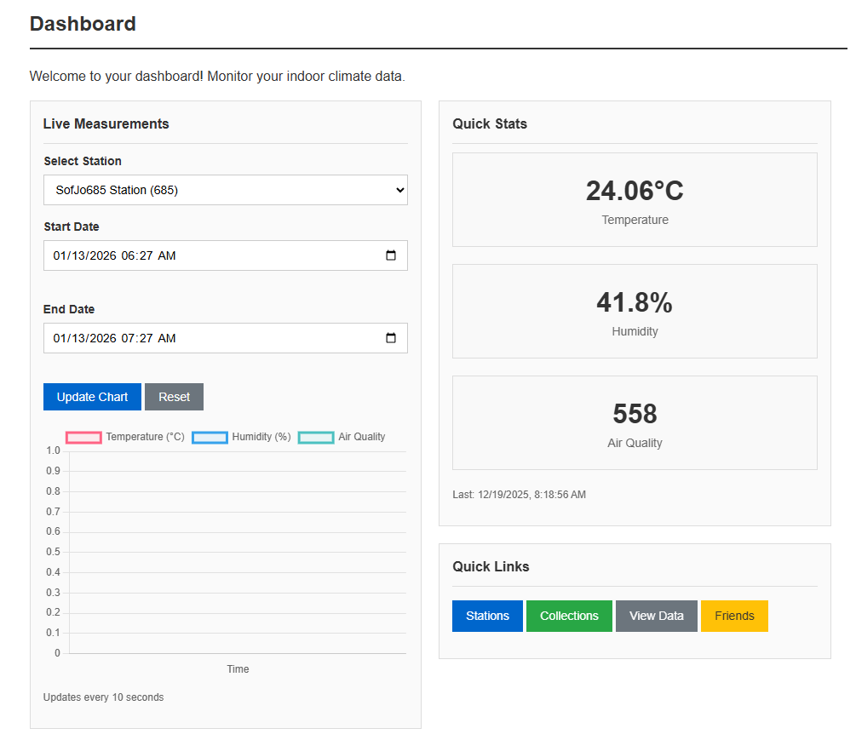

Admin Dashboard
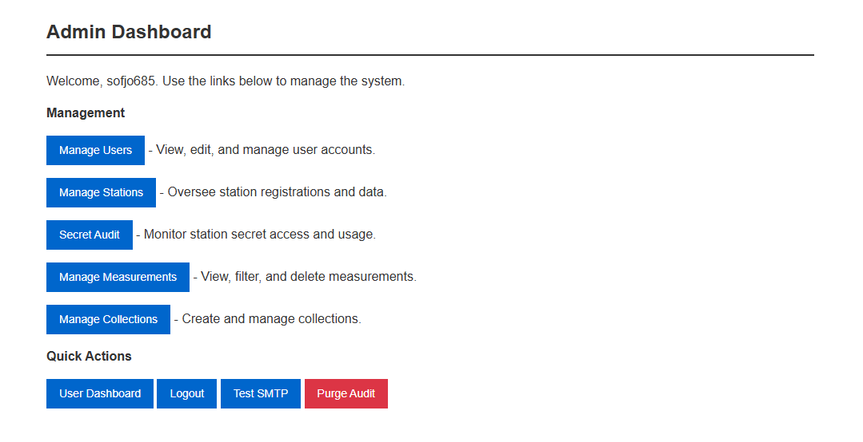

User Stories – Hardware and Assembly

A1 – PVC Holder

Overview
As the operator of Portable Indoor Feedback, a PVC display mount and a base plate were manufactured so that all components can be inserted into the wooden frame (Calendar Week 49).

Work Steps
The PVC base plate was drilled with the following specifications:
- Holes for attaching the Raspberry Pi and the circuit board were drilled with a diameter of 2.5 mm (M2.5).
- Holes for attaching the PVC display holder with M3 countersunk screws: thread drilled with 2.3 mm diameter, countersink with 4 mm diameter.
- Wood screw hole (4 mm diameter countersink) for later attachment to the wooden housing.
- Display attachment holes: 2.5 mm diameter.
- PVC display bracket M3 countersunk screw holes: 3 mm diameter. The ribbon cable outlet opening was cut professionally per specifications.
- All drill holes and side edges were deburred. Countersinks for the countersunk screws were made per specifications.
- All parts were marked with the personal IAM code (SOFJO685).
- The touch display was screwed to the display bracket using the 5 mm spacer sleeves supplied.
- The Raspberry Pi was attached to the base plate using the supplied 5 mm spacer sleeves and M2.5 screws.
- Both plates (display bracket and base plate) were screwed together using the M3 countersunk screws.
- All safety regulations in the workshop and when operating the machines were observed throughout.

A2 – Printed Circuit Board

Overview
As the operator of Portable Indoor Feedback, a printed circuit board was manufactured to serve as an interface between the Raspberry Pi, sensors, and actuators, allowing the sensors to be integrated neatly into the station (Calendar Week 51).

Work Steps
- Components were selected according to the circuit diagram (sensors excluded).
- All components were professionally mounted on the circuit board and soldered. All safety regulations for carrying out the soldering work were observed.
- The circuit board was screwed onto the PVC base plate using the 5 mm spacer sleeves.
- The circuit board was marked with the IAM code (SOFJO685).

A3 – Power Supply

Overview
As the operator of Portable Indoor Feedback, a power supply was established so that the station could be put into operation (Calendar Week 03).

Work Steps
- The power supply cable was cut on the USB side (+/− 20 cm). Both ends were stripped.
- The ground braid was twisted and covered with heat-shrink tubing, leaving 5 mm of braid at the end for electrical connection.
- 5 mm of the +5V stranded wire was stripped. Both strands were covered with heat-shrink tubing.
- The plug side was connected to the Power_INPUT screw terminal on the circuit board.
- The USB-C side was connected to the Power_to_PI screw terminal on the circuit board.
Additionally, as an optional enhancement, strain relief was created with 2 holes in the base plate to secure the cable on the plug side.

A4 – Sensors 1 (MQ135 Gas Sensor)

Overview
As the operator of Portable Indoor Feedback, the MQ135 gas sensor was connected and tested in order to obtain data on air quality (Calendar Week 05).

Work Steps
- All necessary components (MQ135 sensor module and ADS1115 16-bit ADC converter module) were checked and confirmed.
- Pin headers were soldered onto both the MQ135 sensor module and the ADS1115 converter module.
- The circuit was assembled according to the diagram on the Digilab breadboard (the Raspberry Pi has no built-in analog-to-digital converter, so the ADS1115 is required to read the analog MQ135 output).
- The I2C address of the ADS1115 was determined and inserted into the configuration file.
- The sample program (MQ135/test.py) was loaded and the sensor values were successfully read out, confirming correct operation.

A5 – Sensors 2 (Light and Barometric Sensors)

Overview
As the operator of Portable Indoor Feedback, the GY302 light sensor (BH1750) and the BME280 barometric sensor were connected and tested in order to obtain data on temperature, air pressure, and brightness (Calendar Week 09).

Work Steps
- All necessary components (BH1750 light sensor module and BME280 barometric sensor module) were checked and confirmed.
- A socket strip with cable was soldered to the BH1750 light sensor module.
- A socket strip with cable was soldered to the BME280 barometric sensor module (noting the pin assignment carefully).
- Both sensors were assembled on the Digilab breadboard. GND (PIN 9), SDA (Pin 2), and SCL (Pin 3) were distributed in parallel to both sensors. VCC of the BH1750 was connected to +5V (Pin 2); VCC of the BME280 was connected to +3.3V (Pin 1). The CSB and SDO ports of the BME280 were not connected.
- The I2C addresses of both sensors were determined and configured. Function tests were carried out successfully using the test programs BME280/test.py and BH1750/test.py.

A6 – Assembly

Overview
As the operator of Portable Indoor Feedback, all parts were assembled so that the complete station could be tested (Calendar Week 11).

Work Steps
- All necessary components were checked and confirmed before assembly.
- The wooden housing was assembled from its 3 parts: the frame, the removable cover, and the rear panel for insertion.
- The power supply was connected to the circuit board.
- The display was connected (power supply to the corresponding connection on the circuit board).
- All sensors were plugged into the designated slots on the circuit board.
- The light sensor (BH1750) and barometric sensor (BME280) were mounted on the rear breadboard of the housing.
- The PVC bracket with Raspberry Pi and display was installed in the housing. The USB-C cable was connected to the Raspberry Pi.
- The push button was planned and attached independently, with care taken to ensure the wires were long enough to allow the display and bracket to still be inserted and removed.
- A function test of the fully assembled station was performed successfully. Photos of the circuit in the housing were taken and a video demonstrating the working station was recorded.

A7 – Lighting (LED Strip)

Overview
As the operator of Portable Indoor Feedback, an LED light strip was connected to the station and tested so that the station can be illuminated (Calendar Week 13).

Work Steps
- All necessary components were checked and confirmed before starting.
- The LED strip was cut to the required length for the lower edge of the housing.
- Connection wires were soldered to the separation point of the LED strip: red wire for + (positive) and black wire for − (negative). Care was taken to ensure the strands were long enough so that the display and bracket can still be inserted and removed.
- The LED strip was attached to the lower edge of the housing in accordance with the example photos provided.
- A function test of the LED strip was successfully completed.
- As an optional enhancement, a push button for manually switching the LED lighting on and off was planned and installed, with the wiring routed to allow continued removal of the display bracket.
- Photos of the assembly procedure and a video showing the LED lighting in operation were documented.

